Supplementary Information for the paper

**Distributional impacts of fleet-wide change in light duty transportation: mortality risks of PM2.5 emissions from electric vehicle and tier 3 conventional vehicles**

# Madalsa Singh1*, Christopher W. Tessum2, Julian D. Marshall3, Inês M.L. Azevedo1,4,5, 6

1Department of Energy Science and Engineering, Stanford University, Stanford, CA, United States of America

2Department of Civil and Environmental Engineering, University of Illinois at Urbana-Champaign, Urbana, IL, United States of America

3Department of Civil and Environmental Engineering, University of Washington, Seattle, WA, United States of America

4Precourt Institute for Energy, Stanford University, Stanford, CA, United States of America

5Woods Institute for the Environment, Stanford University, Stanford, CA, United States of America

6Nova School of Business and Economics, Carcavelos, Portugal

**Section S.1**

**Estimating LDV vehicle miles traveled (VMT) in census tracts:** We use VMT driven by the LDV fleet at the census tract to estimate air pollution and carbon dioxide emissions from conventional vehicles. (current fleet as well as Tier 3 ICV). National Emissions Inventory publishes VMT and total air pollutant emissions at the county level, but we further downscale this inventory to census tract levels to approximate where and how much these vehicles are driven. We account for differences in household characteristics such as total vehicles owned, number of members in households, and average vehicle miles traveled. Fine resolution emissions inventory is important to accurately understand the health impacts of air pollution, especially in urban areas [1]–[4].

We use the National Emissions Inventory 2017 supporting data for on-road activity[1] to find the county wide VMT for gasoline passenger cars and trucks (SI figure 1, SI figure 2). We then use Local Area Transportation Characteristics by Household 2017 (LATCH) data from the Bureau of Transportation Statistics (BTS) to downscale county-level VMT census tract level [5], [6]. LATCH estimates the average weekday VMT (per day) for all census tracts at the household level through the regression-based analysis of the National Household Transport Survey (2017) and the American Community Survey (ACS). LATCH divides NHTS data into six geographic areas, classifies them based on urban, suburban, or rural categorization, and further estimates household miles based on different numbers of vehicles and member sizes in the household. Using counts of households and LATCH estimated vehicle miles traveled, we can estimate the total weekday miles driven in each census tract and proportionally redistribute the county’s total NEI miles to census tracts.

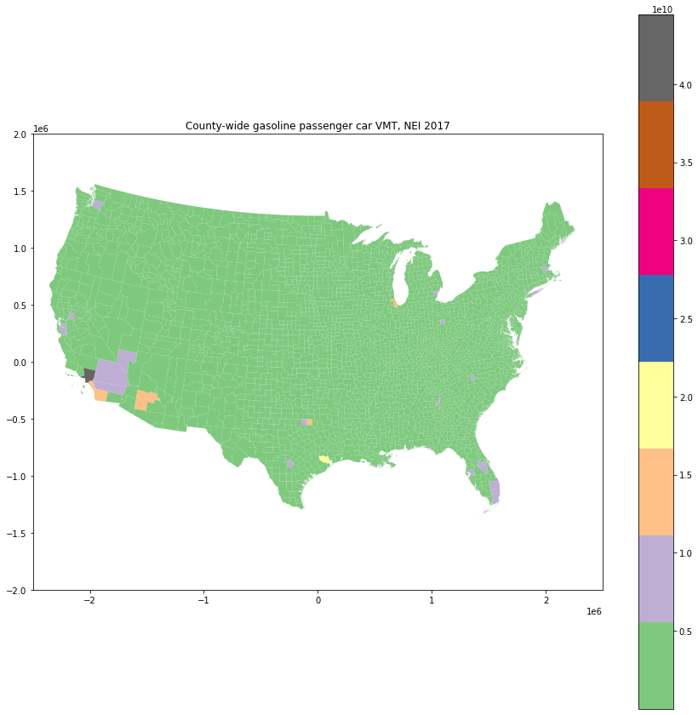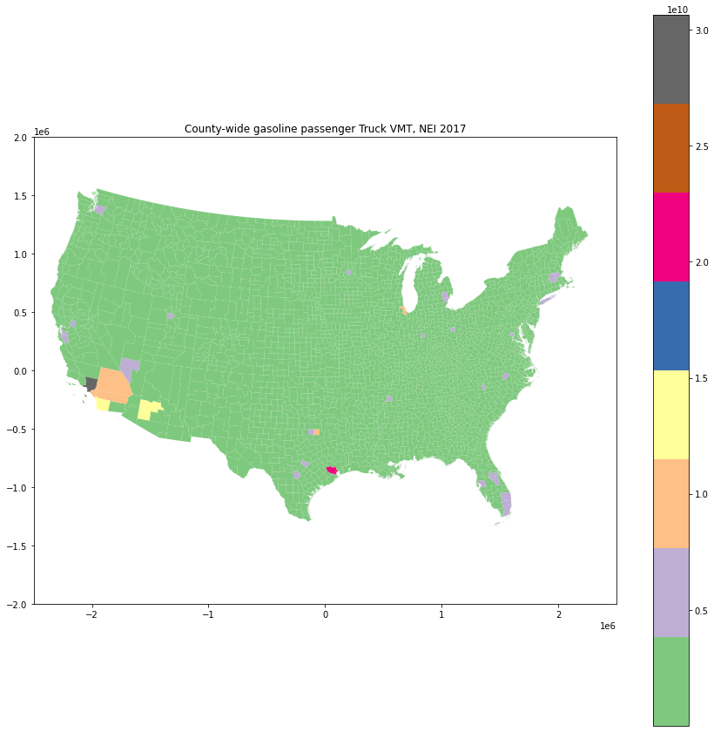

Figure S 1: County-wide gasoline passenger car (left) and truck (right) vehicle miles traveled as per the National Emissions Inventory, 2017.

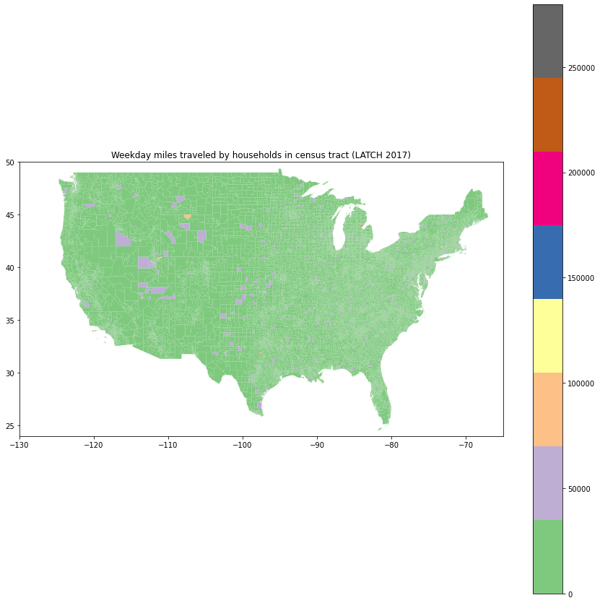

Figure S 2 : Weekday miles traveled by households in census tracts as per the LATCH 2017 data [5]

We use the average weekday miles at census tract level to redistribute the county total VMT to find total VMT at census tract level as follows (figure 4, 5):

$$VMT_{census tract}= \frac{NEI VMT_{county} X Weekday miles driven by all households_{census tract}}{\sum_{all census tracts in a county}{Weekday miles driven by all households_{census tract}}}$$

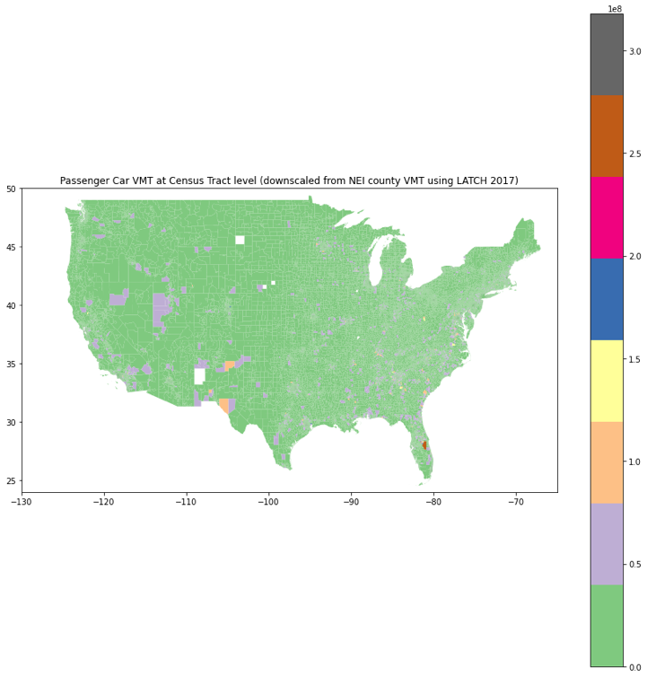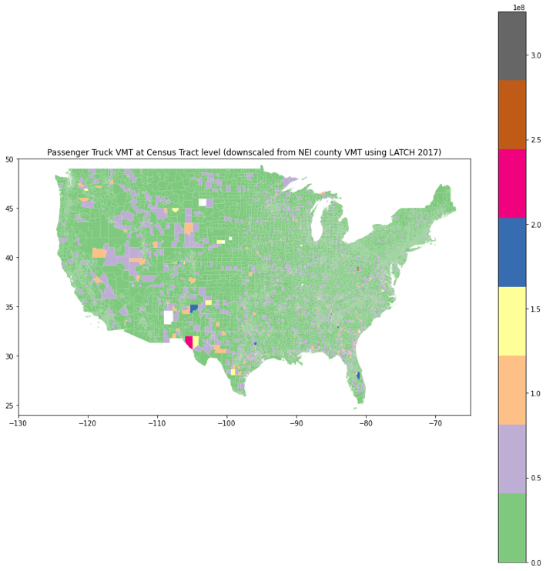

Figure S 3: Downscaled Census Tract VMT using county wide NEI VMT using LATCH and ACS census data on vehicle ownership and number of households.

We also run a scenario using county-level VMT and pollution data (as opposed to downscaling it to census tract levels). The results are given below in figure S17.

**Section S.2**

**Vehicle emissions standards:**

1. **Tier 3 emissions standards on FTP and SFTP drive tests**[2]**:**

Regulated by Environment Protection Agency (EPA), emissions standards set quantitative limits of pollutant emissions that new vehicles can emit per mile. Stringent vehicle emissions standards have drastically reduced criteria air pollutants from light duty vehicles (LDV). Between Tier 1 (1994) and Tier 3 standards (2017), per mile gasoline NOx and PM2.5 limits under regulatory test conditions have decreased by 86% and 90% respectively [1], [2]. Tier 3 emissions standards, enacted in 2017, introduced some of the most stringent limits that manufacturers need to adhere to under laboratory testing conditions for their total fleet in a year as well as for individual vehicles. Vehicles are tested over different drive schedules such as Federal Test Procedure or FTP (city driving conditions), US06 (high acceleration aggressive driving), SC03 (driving with air conditioning), and Supplemental FTP (a mixture of city drive cycles, aggressive driving with acceleration, and driving with air conditioning; SFTP = 0.35 × FTP + 0.28 × US06 + 0.37 × SC03). Departing from previous standards, Tier 3 standards introduced a limit on per mile NMOG + NOx emissions instead of limits of NMOG and NOx separately along with per mile limits for PM2.5, carbon monoxide (CO) and formaldehyde (HCHO). Certification limits denote the actual emissions per mile emitted by a tested vehicle for specific conditions and drive cycles. Certification limits for individual vehicles are used to assign “bins”, for e.g., a vehicle assigned in Tier 2 Bin 5 emitted less than 90 mg/mile of NOx, 70 mg/mile NMOG, and 10 mg/mile PM2.5 while a vehicle in Tier 3 Bin 70 emitted less than 3 mg/mile of PM2.5 and 70 mg/mile of NOX + NMOG emissions. Tier 2 emissions standards aimed for 2016 fleet-wide average NOX levels of 70 mg/mile. No such limit was put for NMOG, PM2.5. Tier 3 emissions standards introduced a combined limit on per mile NMOG + NOx emissions instead of separate limits and in 2022 aimed for fleetwide average NOx + NMOG limit of 51 mg/mile and 30 mg/mile by 2025. SI table 1, 2, 3 show the evolution of exhaust emission standards for Tier 1, 2, 3 standards respectively [9].

Under Tier 3 standards, like Tier 2 standards, manufacturers must certify their vehicles in one of the seven available “certification bins” and must meet fleet-average emissions standards for their vehicle fleet in a given model year. Tier 3 standards are more stringent than Tier 2 standards and include a few new changes:

* Both the certification limits (bins) and the fleet average standards are expressed in the sum of NMOG + NOX emissions rather than separately
* The required emissions durability has been increased to 150,000 miles up from 120,000 miles.

|  |  |  |  |  |  |  |  |  |  |  |  |  |
| --- | --- | --- | --- | --- | --- | --- | --- | --- | --- | --- | --- | --- |
| Category expansion | 50,000 miles/5 years | | | | | | 100,000 miles/10 years1 | | | | | |
|  | THC | NMHC | CO | NOx diesel | NOx gasoline | PM | THC | NMHC | CO | NOx diesel | NOx gasoline | PM |
| passenger cars | 0.41 | 0.25 | 3.4 | 1 | 0.4 | 0.08 |  | 0.31 | 4.2 | 1.25 | 0.6 | 0.1 |
| light light duty trucks | - | 0.25 | 3.4 | 1 | 0.4 | 0.08 | 0.8 | 0.31 | 4.2 | 1.25 | 0.6 | 0.1 |
| light light duty trucks | - | 0.32 | 4.4 | - | 0.7 | 0.08 | 0.8 | 0.4 | 5.5 | 0.97 | 0.97 | 0.1 |

Table S 1: Tier 1 Emissions Standards for passenger cars and light duty trucks, FTP drive cycle (gram/mile)

|  |  |  |  |  |  |
| --- | --- | --- | --- | --- | --- |
|  | Emission Limits (grams/mile) | | | | |
| Standard | NOx | NMOG | PM | CO | HCHO |
| Bin 1 | 0 | 0 | 0 | 0 | 0 |
| Bin 2 | 0.02 | 0.010 | 0.01 | 2.1 | 0.004 |
| Bin 3 | 0.03 | 0.055 | 0.01 | 2.1 | 0.011 |
| Bin 4 | 0.04 | 0.070 | 0.01 | 2.1 | 0.011 |
| Bin 5 | 0.07 | 0.090 | 0.01 | 4.2 | 0.018 |
| Bin 6 | 0.10 | 0.090 | 0.01 | 4.2 | 0.018 |
| Bin 7 | 0.15 | 0.090 | 0.02 | 4.2 | 0.018 |
| Bin 8a | 0.20 | 0.125 | 0.02 | 4.2 | 0.018 |
| Fleet average target (2017) | 0.07 | -- | -- | -- | -- |

Table S 2: Tier 2 Standards (gram/mile) for Full Useful Life (120,000 miles) tested under the Federal Test Procedure (FTP)[3]

|  |  |  |  |  |
| --- | --- | --- | --- | --- |
|  | Emission Limits (grams/mile) | | | |
| Standard | NOx + NMOG | PM | CO | HCHO |
| Bin 1 | 0 | 0 | 0 | 0 |
| Bin 20 | 0.02 | 0.003 | 1 | 0.004 |
| Bin 30 | 0.03 | 0.003 | 1 | 0.004 |
| Bin 50 | 0.051 | 0.003 | 1.7 | 0.004 |
| Bin 70 | 0.07 | 0.003 | 1.7 | 0.004 |
| Bin 125 | 0.125 | 0.003 | 2.1 | 0.004 |
| Bin 160 | 0.160 | 0.003 | 4.2 | 0.004 |
| Fleet average target (2022) | 0.05 | -- | -- | -- |
| Fleet average target (2025) | 0.03 | -- | -- | -- |

Table S 3: Tier 3 Emissions Standards, FTP test procedure (the NMOG + NOX limits must be additionally met over the HFET cycle). The standards are applicable to all vehicles regardless of the fuel type[4]

Figure S 4: Tier 3 fleet average NOX + NMOG FTP standards (mg/mile)

To estimate PM2.5 related health damages from a fleet-wide shift to new tier 3 vehicles, we assume emissions rate equal to exhaust emissions standards in FTP and Supplemental FTP drive cycles as two possible scenarios analysis. For NOX and NMOG, fleet average target exhaust standard for 2022 is used, while all vehicles meet the PM2.5 standards.



Figure S 5: Tier 3 PM certification and in-use emission standards (in mg/mile) for FTP and SFTP (US06) drive cycles[5].

1. **NOX and NMOG ratio:**

Tier 3 standards regulate combined NOX + NMOG level rather than individual emissions. However, total emissions of NOX and NMOG are separately needed to tease out air quality impacts as both pollutants have different reaction mechanisms in InMAP [10]. We analyzed Environmental Protection Agency’s annual certification data [11] from 1160 gasoline LDV with model year 2017- 2023 and found no strong association between the certification levels of NOX and NMOG (SI figure 6). Instead, to estimate individual emissions, we assume three ratios of NOX and NMOG in exhaust emissions standards -- 50:50, 30:70, and 70:30 – to calculate the PM2.5 related health impacts.



Figure S 6 : Certification level NMOG and NOx data from EPA’s annual certification data for LDV (Tier 3 model year 2017-2023)

**Section S.3**

**Health damages from electric vehicles**

1. **Calculating energy consumption per mile and total electricity required for electric vehicles for each county:** Energy consumption of an electric vehicle depends on ambient temperature and driving characteristics [12], [13]. EV energy consumption is particularly sensitive to ambient temperature. Using updated data from our previous work [14] we find out energy consumption per mile of Nissan Leaf 2018 and Tesla Model S 2017 for each county (SI figure 10). Using NEI 2017 data for county level LDV VMT (SSI figure 11) we find out total electricity needed for each county (SI figure 12) and aggregate it up to NERC level.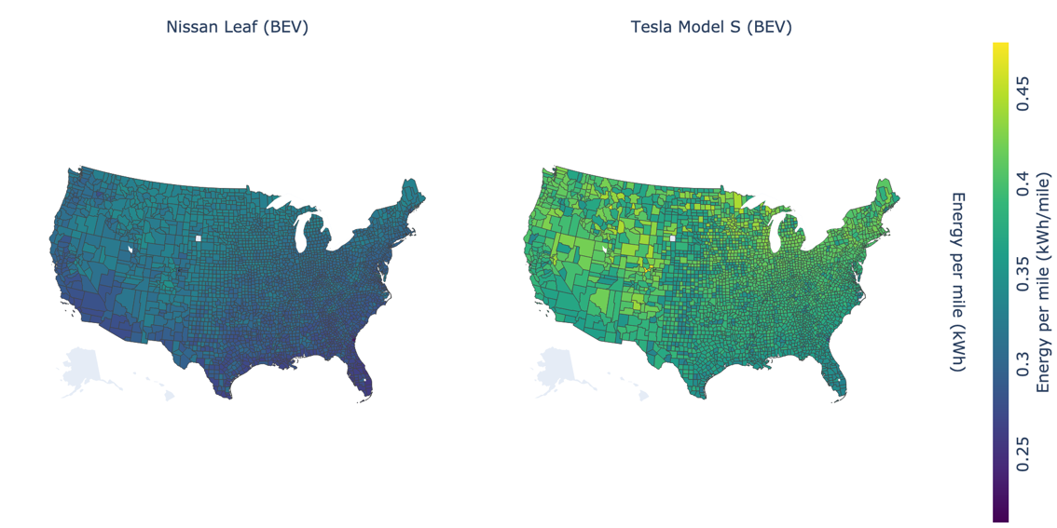

Figure S 7 : Energy per mile (kWh/mile) for 2018 Nissan Leaf and 2017 Tesla Model S with changing ambient temperature and drive cycle for each county in the United States. For additional details on refer to [13], [14]

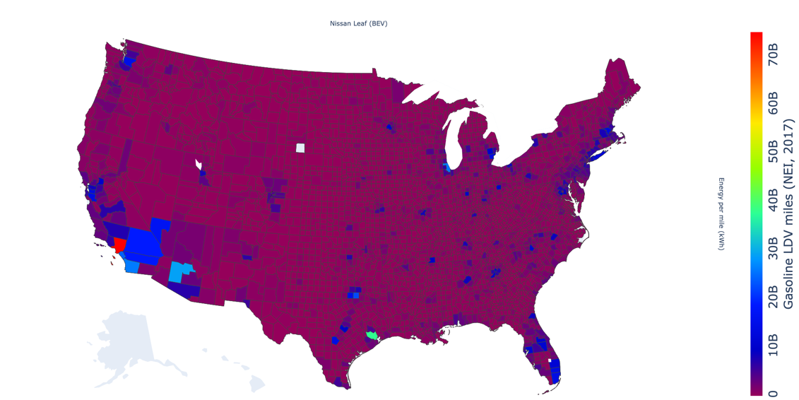

Figure S 8 : Total gasoline VMT for each county of the United States as per NEI 2017. Refer to SI Section S.1 for more details.

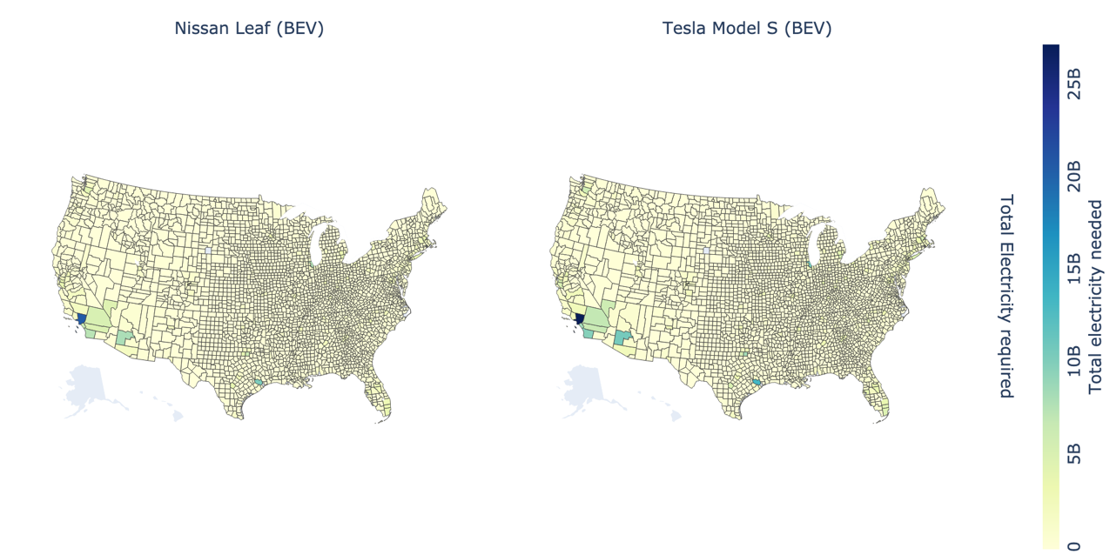

Figure S 9: Total electricity (in kWh) required to drive total NEI vehicle miles traveled for each electric vehicle.

1. **Electricity generation characteristics in NERC regions :** We use e-grid data from 2019 to find the total electricity generation in NERC region along with shares of renewable and non-renewable generation [15]. Only fossil infrastructure (non-renewable) contributes to health damages from electricity generation. Electricity produced in a region with a high share of fossil generation will have more health damages than a region with lower share of fossil fuels. Damages attributed to electric vehicles are in proportion to the total electricity required for fleet-wide shift as calculated previously. For example, a fleet-wide electrification in MRO with Nissan Leaf has health damages equivalent to 12% of total MRO electricity related health damages caused by fossil infrastructure region (66% of the total generation). This characterization considers the generation mix of electricity in each region as well as temperature and drive cycle specific electricity requirement for electric vehicles.

|  |  |  |  |  |  |  |  |  |  |
| --- | --- | --- | --- | --- | --- | --- | --- | --- | --- |
| Region | Total generation (TWh) by NERC region 2019 | Total generation from all non-renewables (TWh) by NERC region 2019 | Total generation from all renewables (TWh) by NERC region 2019 | % non-renewables | %renewables | Total electricity requirement from converting the fleet (TWh) (Leaf) | Total electricity requirement from converting the fleet (TWh) (Leaf) | % electricity of NERC region required for converting the fleet (Leaf) | % electricity of NERC region required for converting the fleet (Tesla) |
| US | 4140 | 3409 | 731 | 82 | 18 | 739 | 982 | 18 | 24 |
| MRO | 448 | 297 | 151 | 66 | 34 | 52 | 68 | 12 | 15 |
| NPCC | 232 | 173 | 58 | 75 | 25 | 68 | 92 | 29 | 40 |
| RFC | 919 | 867 | 52 | 94 | 6 | 170 | 228 | 18 | 25 |
| SERC | 1355 | 1261 | 93 | 93 | 7 | 233 | 306 | 17 | 23 |
| TRE | 414 | 332 | 82 | 80 | 20 | 49 | 65 | 12 | 16 |
| WECC | 739 | 448 | 291 | 61 | 39 | 167 | 223 | 23 | 30 |

Table S 4: Total electricity generation by renewables and non-renewables share for NERC regions in 2019. Source – eGRID. Percentage electricity of the NERC region required for converting to fleet to two possible electric vehicles (Leaf and Tesla Model S).

1. **Power plant air pollutant emissions in NERC regions:**

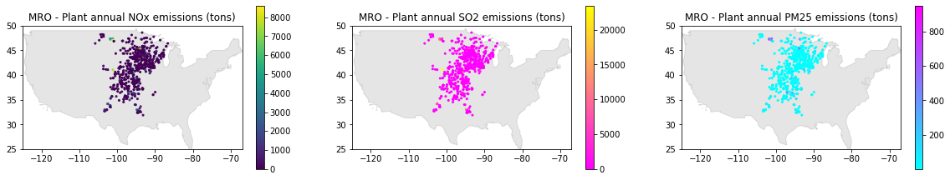

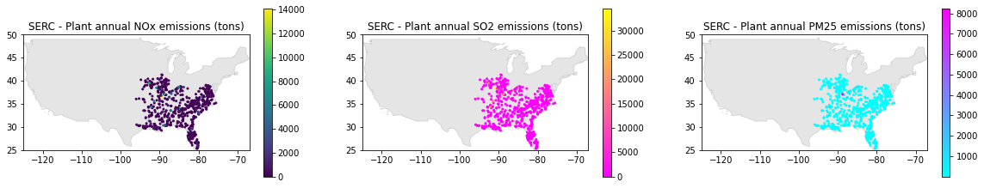

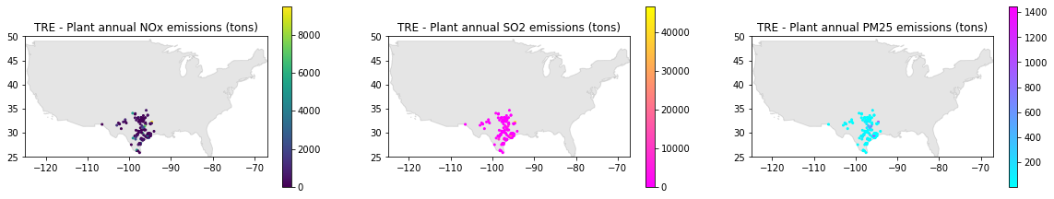

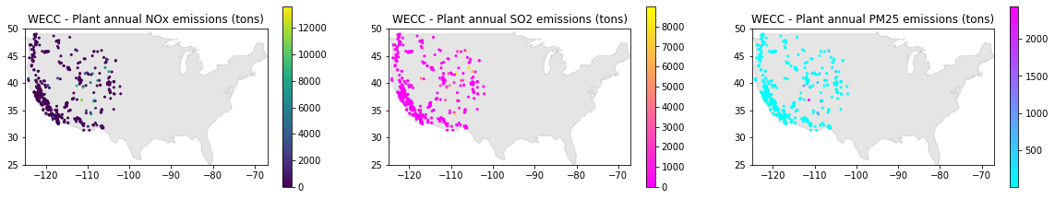

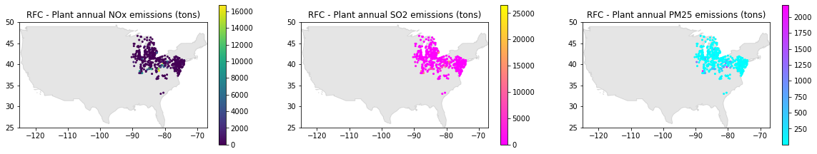 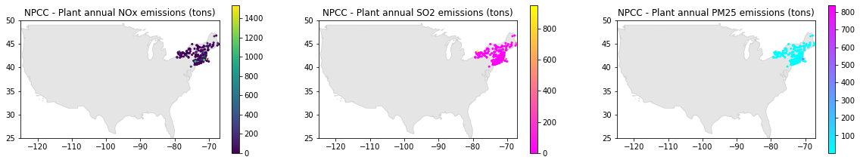

Figure S 10 : Plant annual NOx, SO2, and PM2.5 emissions for each NERC region for the year 2019

Health impacts from electric vehicles (Nissan Leaf) is calculated as following:

$$fraction of total electricity_{leaf, mro} X health impacts_{mro}+ \\ fraction of total electricity_{leaf, npcc} X health impacts_{npcc}+ \\ fraction of total electricity_{leaf, rfc} X health impacts_{rfc}+ \\ fraction of total electricity_{leaf, tre} X health impacts_{tre}+ \\ fraction of total electricity_{leaf, serc} X health impacts_{serc}+$$

$$fraction of total electricity_{leaf, wecc} X health impacts_{wecc}+$$

Health impacts from electric vehicles (Tesla Model S) is calculated as following:

$$fraction of total electricity_{tesla, mro} X health impacts_{mro}+ \\ fraction of total electricity_{tesla, npcc} X health impacts_{npcc}+ \\ fraction of total electricity_{tesla, rfc} X health impacts_{rfc}+ \\ fraction of total electricity_{tesla, tre} X health impacts_{tre}+ \\ fraction of total electricity_{tesla, serc} X health impacts_{serc}+$$

$$fraction of total electricity_{tesla, wecc} X health impacts_{wecc}+$$

Where the fraction of total electricity are given in SI Table 4

1. **Retiring or retrofitting with CCS 50 power plants with highest SO2 emissions**: To model our scenarios which considers a decarbonizing electricity grid, we retired or retrofit with CCS 50 power plants with highest annual SO2 emissions. If retired, we assume that this capacity is replaced with non-polluting power sources. Table S5 and S6 details the list of power plants and state-wise capacity and emissions removed.

|  |  |  |  |  |  |  |  |
| --- | --- | --- | --- | --- | --- | --- | --- |
| **State** | **Number of plants retired/retrofit** | **Sum of Plant nameplate capacity (MW)** | **Sum of Plant annual net generation (MWh)** | **Sum of Plant annual NOx emissions (tons)** | **Sum of Plant annual SO2 emissions (tons)** | **Sum of Plant annual CO2 emissions (tons)** | **Sum of Plant annual PM2.5 emissions (tons)** |
| AR | 2 | 3,600 | 11,174,297 | 9,494 | 29,565 | 13,016,357 | 527 |
| GA | 1 | 3,499 | 9,452,106 | 6,248 | 6,669 | 10,376,634 | 257 |
| HI | 1 | 610 | 2,116,379 | 3,336 | 10,024 | 1,866,084 | 111 |
| IA | 2 | 2,460 | 10,715,991 | 8,744 | 14,352 | 10,923,598 | 320 |
| IL | 4 | 3,818 | 22,091,837 | 10,216 | 46,421 | 24,062,888 | 595 |
| IN | 1 | 3,340 | 9,230,440 | 4,770 | 9,110 | 9,824,728 | 1,729 |
| KY | 3 | 4,310 | 19,639,688 | 15,332 | 32,914 | 22,408,690 | 588 |
| LA | 2 | 3,337 | 5,555,519 | 2,874 | 22,408 | 5,170,150 | 154 |
| MI | 3 | 4,459 | 18,523,310 | 15,882 | 41,862 | 21,046,360 | 184 |
| MO | 4 | 6,113 | 39,029,575 | 39,068 | 88,135 | 39,819,015 | 2,446 |
| ND | 2 | 1,404 | 7,713,671 | 9,282 | 23,696 | 9,520,157 | 704 |
| NE | 2 | 2,752 | 14,036,502 | 10,500 | 28,869 | 14,822,268 | 299 |
| OH | 4 | 7,087 | 35,225,408 | 25,759 | 62,988 | 37,400,746 | 2,426 |
| OK | 1 | 1,716 | 3,350,910 | 4,940 | 6,500 | 3,654,273 | 269 |
| PA | 2 | 2,468 | 10,274,420 | 7,439 | 24,582 | 11,205,514 | 1,032 |
| PR | 2 | 2,262 | 5,033,499 | 11,991 | 20,790 | 4,475,174 | 317 |
| TN | 1 | 2,600 | 10,362,082 | 4,474 | 9,066 | 11,722,242 | 1,277 |
| TX | 8 | 12,548 | 57,347,241 | 35,981 | 138,725 | 63,953,225 | 3,731 |
| WV | 3 | 6,353 | 31,088,033 | 15,751 | 32,651 | 32,764,860 | 2,472 |
| WY | 2 | 3,364 | 13,944,082 | 11,506 | 14,554 | 16,414,047 | 980 |

Table S 5 : State-wise total power plants, capacity, and pollutants removed for modeling the future decarbonized grid.

|  |  |  |  |  |  |  |  |  |  |  |  |
| --- | --- | --- | --- | --- | --- | --- | --- | --- | --- | --- | --- |
| **Plant state abbreviation** | **Plant name** | **Plant primary fuel category** | **Plant capacity factor** | **Plant nameplate capacity (MW)** | **Plant ozone season net generation (MWh)** | **Plant annual NOx emissions (tons)** | **Plant ozone season NOx emissions (tons)** | **Plant annual SO2 emissions (tons)** | **Plant annual CO2 emissions (tons)** | **Plant annual CO2 equivalent emissions (tons)** | **Plant annual PM2.5 emissions (tons)** |
| TX | Martin Lake | COAL | 0.63 | 2,380 | 6,350,776 | 9,710 | 4,477 | 48,782 | 14,785,111 | 14,909,791 | 908 |
| MO | Labadie | COAL | 0.79 | 2,389 | 7,116,123 | 7,935 | 3,309 | 41,928 | 17,236,250 | 17,382,011 | 1,474 |
| TX | W A Parish | COAL | 0.42 | 4,008 | 7,914,251 | 5,652 | 3,192 | 33,870 | 15,206,281 | 15,325,187 | 1,003 |
| OH | Gen J M Gavin | COAL | 0.61 | 2,600 | 6,182,251 | 8,322 | 3,833 | 25,842 | 14,736,057 | 14,851,287 | 565 |
| MI | Belle River | COAL | 0.48 | 1,664 | 2,947,354 | 8,006 | 3,111 | 22,352 | 8,019,970 | 8,080,893 | 12 |
| MO | Rush Island | COAL | 0.75 | 1,242 | 3,712,738 | 3,261 | 1,482 | 19,529 | 8,070,698 | 8,137,732 | 210 |
| NE | Gerald Gentleman Station | COAL | 0.59 | 1,363 | 3,431,541 | 6,197 | 2,942 | 19,403 | 7,307,221 | 7,366,165 | 113 |
| AR | White Bluff | COAL | 0.45 | 1,800 | 4,078,396 | 5,962 | 3,452 | 18,523 | 8,089,453 | 8,145,980 | 331 |
| OH | Miami Fort Power Station | COAL | 0.66 | 1,181 | 2,682,678 | 9,285 | 1,036 | 17,738 | 7,039,341 | 7,097,268 | 792 |
| PA | Keystone | COAL | 0.45 | 1,883 | 3,005,402 | 5,481 | 2,095 | 17,013 | 7,940,373 | 8,004,763 | 963 |
| WV | Pleasants Power Station | COAL | 0.63 | 1,368 | 3,058,455 | 6,560 | 1,500 | 16,295 | 8,161,061 | 8,226,535 | 824 |
| IL | Archer Daniels Midland Co. | COAL | 0.37 | 335 | 453,758 | 299 | 127 | 16,200 | 540,406 | 545,555 | 21 |
| MO | Thomas Hill Energy Center | COAL | 0.83 | 1,182 | 3,573,697 | 11,882 | 3,319 | 16,193 | 9,052,529 | 9,122,430 | 383 |
| KY | Shawnee | COAL | 0.44 | 1,575 | 2,968,225 | 6,986 | 3,502 | 14,696 | 7,498,469 | 7,555,215 | 190 |
| LA | Nelson Industrial Steam Company | OIL | 0.23 | 1,434 | 1,272,500 | 965 | 428 | 14,462 | 1,941,270 | 1,960,063 | 105 |
| PR | Aguirre Plant | OIL | 0.27 | 1,534 | 1,380,351 | 9,109 | 3,583 | 14,240 | 3,194,711 | 3,205,663 | 168 |
| IL | Joppa Steam | COAL | 0.53 | 1,100 | 2,421,312 | 3,341 | 1,555 | 13,231 | 5,892,538 | 5,940,043 | 297 |
| MI | St. Clair | COAL | 0.30 | 1,234 | 1,607,756 | 4,156 | 1,996 | 13,141 | 3,872,108 | 3,901,603 | 10 |
| TX | Harrington Station | COAL | 0.52 | 1,080 | 2,436,918 | 4,043 | 2,016 | 12,703 | 5,510,162 | 5,553,404 | 63 |
| ND | Coyote | COAL | 0.63 | 450 | 1,031,588 | 6,028 | 2,591 | 12,684 | 3,058,364 | 3,082,143 | 448 |
| KY | Ghent | COAL | 0.54 | 2,226 | 4,984,004 | 6,584 | 3,085 | 11,060 | 11,356,337 | 11,450,268 | 378 |
| AR | Independence | COAL | 0.26 | 1,800 | 2,306,382 | 3,532 | 1,903 | 11,042 | 4,926,904 | 4,962,422 | 196 |
| ND | Antelope Valley | COAL | 0.63 | 954 | 2,199,393 | 3,255 | 1,365 | 11,011 | 6,461,793 | 6,511,256 | 256 |
| OH | Cardinal | COAL | 0.61 | 1,880 | 4,555,906 | 4,134 | 1,552 | 10,688 | 10,694,220 | 10,776,021 | 518 |
| IL | Prairie State Generating Station | COAL | 0.82 | 1,766 | 5,734,090 | 4,122 | 1,878 | 10,537 | 13,591,665 | 13,692,138 | 238 |
| MO | New Madrid Power Plant | COAL | 0.50 | 1,300 | 2,052,576 | 15,989 | 6,166 | 10,486 | 5,459,539 | 5,505,765 | 379 |
| TX | Coleto Creek | COAL | 0.63 | 622 | 1,868,687 | 2,742 | 1,438 | 10,401 | 3,915,409 | 3,945,384 | 140 |
| HI | Kahe Generating Station | OIL | 0.40 | 610 | 902,222 | 3,336 | 1,421 | 10,024 | 1,866,084 | 1,872,483 | 111 |
| WV | Harrison Power Station | COAL | 0.64 | 2,052 | 4,859,693 | 3,912 | 1,532 | 10,011 | 12,009,520 | 12,105,271 | 1,457 |
| TX | Welsh Power Plant | COAL | 0.44 | 1,116 | 2,698,616 | 4,981 | 3,087 | 9,880 | 5,218,554 | 5,258,773 | 23 |
| NE | Nebraska City Station | COAL | 0.57 | 1,390 | 3,518,295 | 4,304 | 2,034 | 9,465 | 7,515,047 | 7,574,128 | 186 |
| IN | Gibson | COAL | 0.32 | 3,340 | 5,118,173 | 4,770 | 1,750 | 9,110 | 9,824,728 | 9,908,618 | 1,729 |
| TN | Cumberland | COAL | 0.45 | 2,600 | 4,746,868 | 4,474 | 2,082 | 9,066 | 11,722,242 | 11,814,694 | 1,277 |
| OH | W H Zimmer Generating Station | COAL | 0.37 | 1,426 | 2,503,876 | 4,018 | 1,174 | 8,721 | 4,931,128 | 4,969,085 | 551 |
| TX | Oak Grove | COAL | 0.78 | 1,795 | 5,859,509 | 4,543 | 2,212 | 8,595 | 13,796,169 | 13,900,452 | 1,496 |
| WY | Jim Bridger | COAL | 0.48 | 2,442 | 4,964,454 | 6,550 | 3,070 | 8,226 | 11,844,068 | 11,936,734 | 767 |
| LA | Big Cajun 2 | COAL | 0.16 | 1,903 | 1,437,060 | 1,909 | 1,046 | 7,946 | 3,228,880 | 3,253,248 | 49 |
| IA | Walter Scott Jr. Energy Center | COAL | 0.44 | 1,648 | 3,607,357 | 5,044 | 2,833 | 7,630 | 6,425,915 | 6,476,464 | 205 |
| TX | San Miguel | COAL | 0.53 | 410 | 979,852 | 1,820 | 984 | 7,579 | 2,580,845 | 2,602,477 | 71 |
| PA | Seward | COAL | 0.56 | 585 | 1,189,813 | 1,957 | 727 | 7,569 | 3,265,141 | 3,291,096 | 69 |
| KY | D B Wilson | COAL | 0.68 | 509 | 1,287,279 | 1,762 | 609 | 7,157 | 3,553,884 | 3,581,343 | 20 |
| TX | Tolk Station | COAL | 0.25 | 1,136 | 1,619,719 | 2,489 | 1,669 | 6,915 | 2,940,694 | 2,962,497 | 27 |
| IA | Louisa | COAL | 0.61 | 812 | 2,408,502 | 3,700 | 2,021 | 6,722 | 4,497,683 | 4,535,168 | 115 |
| GA | Bowen | COAL | 0.31 | 3,499 | 5,505,335 | 6,248 | 1,880 | 6,669 | 10,376,634 | 10,453,548 | 257 |
| PR | Palo Seco Plant | OIL | 0.22 | 728 | 672,174 | 2,882 | 1,420 | 6,550 | 1,280,463 | 1,284,853 | 149 |
| OK | Muskogee | COAL | 0.22 | 1,716 | 1,586,561 | 4,940 | 2,300 | 6,500 | 3,654,273 | 3,679,898 | 269 |
| IL | Newton | COAL | 0.60 | 617 | 1,561,212 | 2,455 | 1,038 | 6,453 | 4,038,279 | 4,067,538 | 38 |
| MI | J H Campbell | COAL | 0.60 | 1,561 | 3,823,810 | 3,720 | 1,649 | 6,369 | 9,154,282 | 9,223,848 | 162 |

Table S 6: 50 power plants with highest SO2 annual emissions retired or retrofit with CCS.

**Section S.4**

**Comparison between different dose-response functions:**

In this section, we compare four concentration-response functions (CRFs). Many studies use PM2.5–mortality relationships described by Krewski et al. [16] and Lepeule et al. [17] which rely on evidence from follow-ups long-term US cohort studies of air pollution conducted by the American Cancer Society (ACS) and Harvard Six Cities studies respectively. These studies found relative risks of all-cause mortality of 1.06 (95% CI: 1.04–1.08) and 1.14 (95% CI: 1.07–1.22), respectively, for a 10 μg/m3 increase in PM2.5. The third CRF, the Global Exposure Mortality Model (GEMM) reported by Burnett et al. [18] relies on data from 41 cohort studies from 16 countries to estimate the shape of the association between ambient PM2.5 exposure and non-accidental mortality. The GEMM function is supralinear at lower concentrations, near-linear at higher concentrations, and applies a counterfactual threshold of 2.4 μg/m3, the lowest concentration observed in any of the cohort studies. It is assumed that PM2.5 exposure has no effect on health below this level. The fourth CRF is from Tessum et al. [19]  and is based on the relationship described by Nasari et al.[20] and Burnett et al. [18] but is derived from the ACS cohort instead of the full list of 41 cohorts. Hystad et al. [21] argue that the use of the GEMM function for global disease burden estimation warrants caution since much of the global population is exposed to PM2.5 concentrations above the ranges observed in the cohort studies that inform the GEMM function, but we consider it an appropriate choice for this analysis since the US is well represented in PM2.5 cohort studies included in the GEMM function.

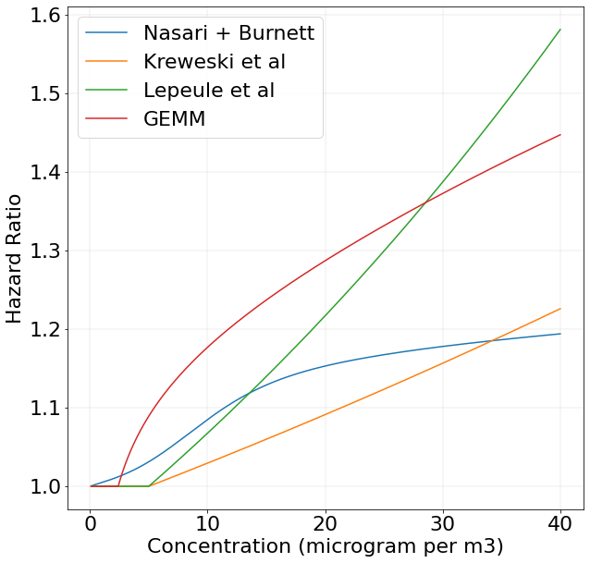

Figure S 11 Comparison of hazard ratio (HR (Ci)) of different concentration-response functions. In this study we use GEMM (red) for calculating premature mortality.

**Section S.5 : Geographic boundaries**

1. **Map of Census regions of the United States**

For results, we divide the states and MSAs into different census regions of the United States as outlined by the Census Bureau [22].

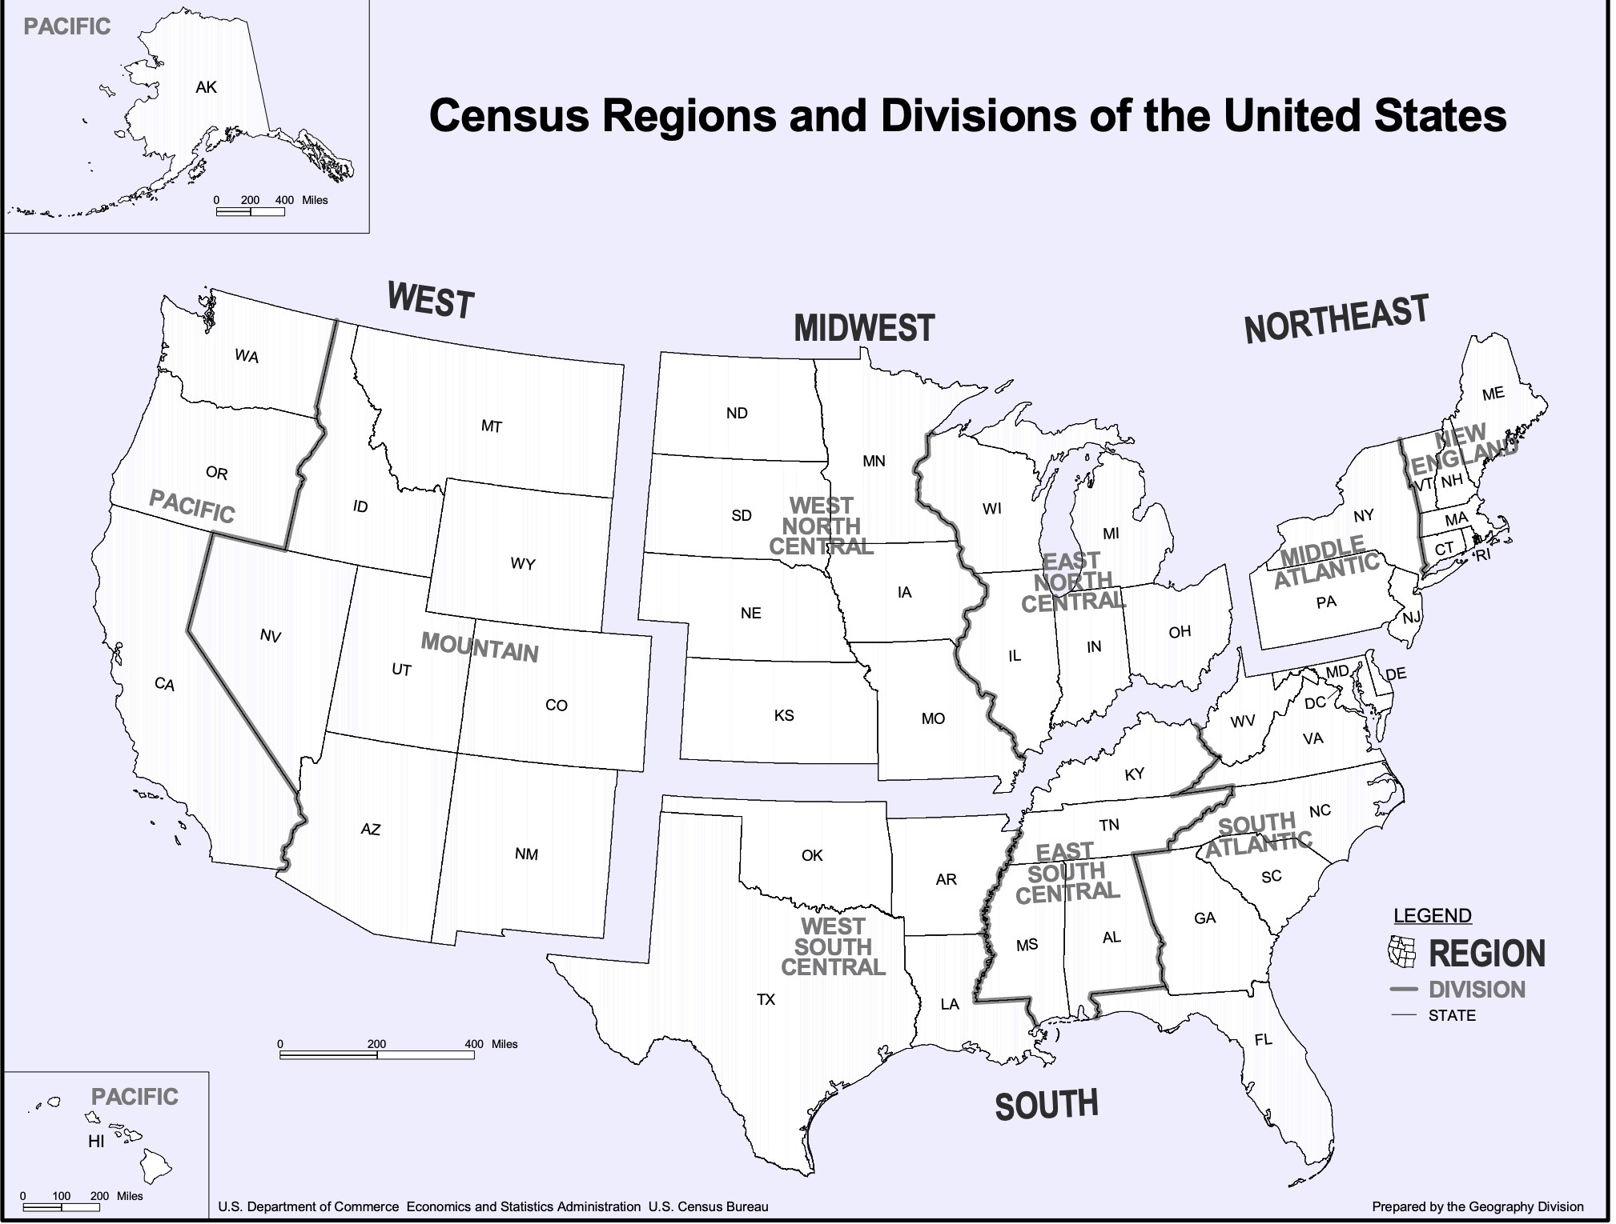

Figure S 12 : Census regions and divisions of the United States used in this study.

1. **Map of NERC regions**

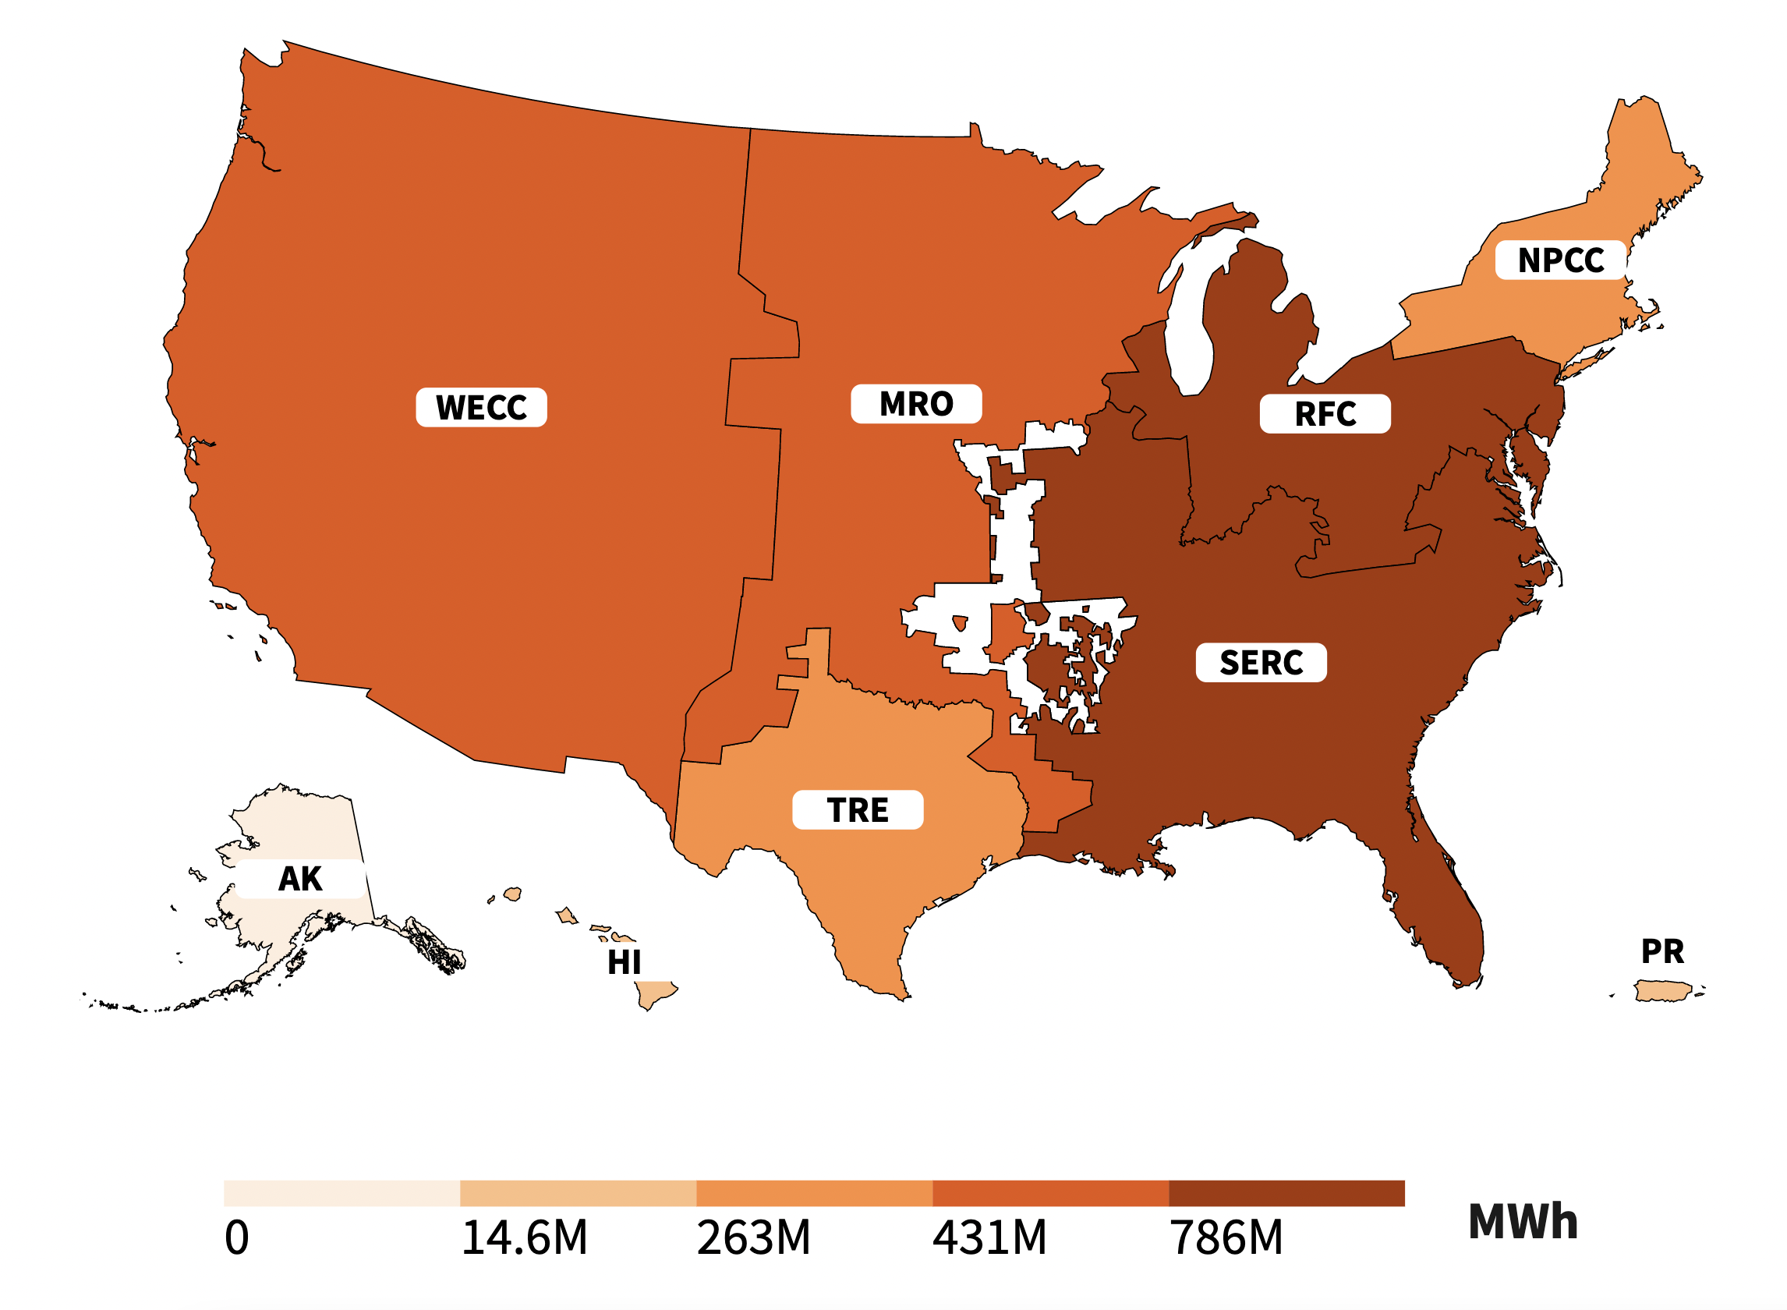

Figure S 13: Map of NERC regions as per the EPA Power Profiler (YEAR 2019). The color bar denotes the total electricity production in each NERC region.

1. **Mapping input emissions (area and point source) to InMAP model grid**

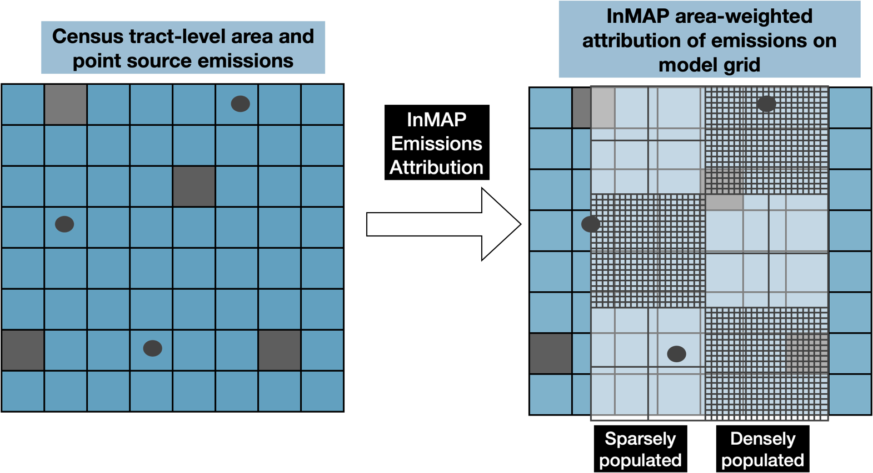

Figure S 14 : Attributing area emissions sources (grey squares) and point sources (circles) to the InMAP model grid.

1. **Geographic distribution of all-cause mortality 2019 (CDC) and the hypothetic underlying incidence rate, as calculated by Apte et al. [23]**

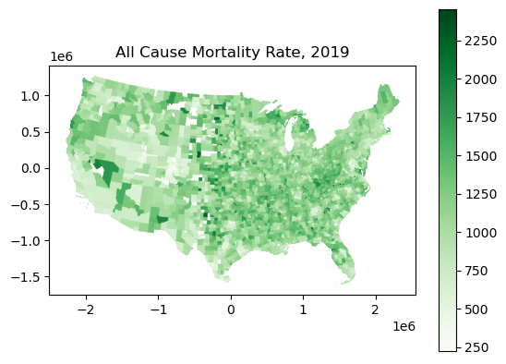

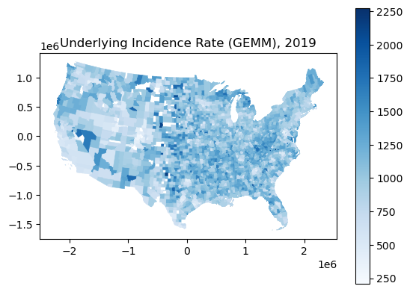

Figure S 15: All-cause mortality and Underlying incidence rate by county for the year 2019. All-causes mortality is taken from CDC (Center for Disease Control) for the year 2019 and the underlying incidence rate is calculated as per Apte et al [23]

**Section S.6 : Results**

This section compiles results for alternate scenarios and sensitives provided in the main manuscript.

1. **Change in PM2.5 concentration from different transportation choices**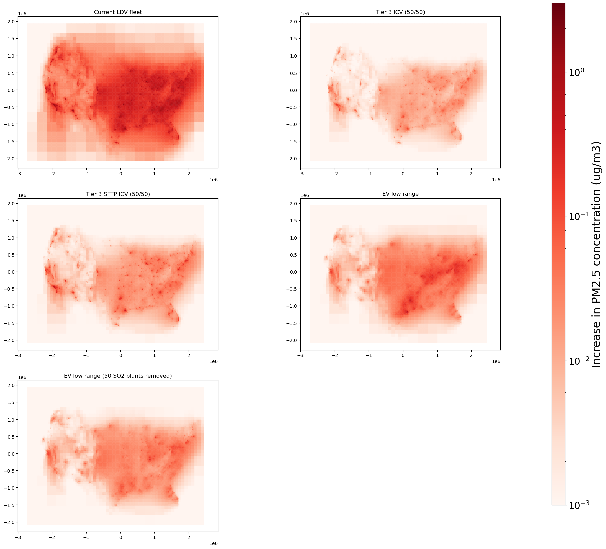

Figure S 16: PM2.5 concentration attributable to the current fleet and fleet-wide change to Tier 3 ICVs and low-range EVs charged on the current grid and charged on a grid without 50 most SO2 polluting power plants.

1. **Total mortality (deaths) and mortality rate (deaths per 100,000 people) from current LDV, all scenarios of Tier 3 ICV, and EVs charged on current and future grid (50 most SO2 power plants are retired or retrofit with CCS):**

Mortality rate of total population or of a specific race or ethnicity is calculated as following:

$$Mortality rate_{total or race, ethnicity }=\frac{Deaths_{total or race, ethnicity}}{Population counts_{total or race, ethnicity}} X 100,000$$

For Tier 3 ICV, the ratio denotes the ratio between NOx and NMOG in the emission standard. For example, 30/70 denotes on FTP drive cycle denotes that if the fleet has to pass the FTP drive cycle combined NOx + NMOG emission standard for Model Year 2022 (51mg/mile), it would mean 30% of it is released as NOx (15.3mg/mile) and 70% as NMOG (35.7mg/mile)

|  |  |  |  |  |  |  |  |  |  |  |
| --- | --- | --- | --- | --- | --- | --- | --- | --- | --- | --- |
| Transportation scenario | Total Deaths (GEMM) | White Deaths | Black Deaths | Latino Deaths | Asian Deaths | Total Mortality rate | White Mortality rate | Black Mortality rate | Latino Mortality rate | Asian Mortality rate |
| Current LDV fleet | 16,003 | 9,118 | 2,389 | 2,997 | 908 | 49.33 | 46.6 | 59.7 | 50.6 | 51.5 |
| Tier 3 FTP (50/50) | 1,296 | 647 | 199 | 305 | 97 | 3.99 | 3.31 | 4.97 | 5.16 | 5.49 |
| Tier 3 SFTP (50/50) | 3,054 | 1,464 | 476 | 758 | 242 | 9.41 | 7.49 | 11.93 | 12.82 | 13.77 |
| Tier 3 FTP (30/70) | 1,256 | 616 | 194 | 305 | 96 | 3.87 | 3.15 | 4.85 | 5.15 | 5.43 |
| Tier 3 FTP (70/30) | 1,334 | 678 | 204 | 306 | 98 | 4.11 | 3.46 | 5.09 | 5.16 | 5.55 |
| EVs (low range – high range) (current grid) | 2,136-2,806 | 1,362-1,790 | 301-395.2 | 297-390 | 103-136 | 6.59-8.65 | 6.97-9.15 | 7.53-9.89 | 5.03-6.6 | 5.86-7.72 |
| EVs (low range – high range) (future grid) | 1,270-1,675 | 770 – 1,016 | 178 - 234 | 204- 269 | 72-95.5 | 3.91-5.16 | 3.94-5.19 | 4.45-5.86 | 3.45-4.55 | 4.10-5.42 |

Table S 7 : Total population and race/ethnicity specific premature mortality and mortality rate for all scenarios considered in the study.

1. **Using county level emissions inventory for results rather than downscaled census tract emissions inventory:** National Emissions Inventory (NEI) reports LDV emissions and miles traveled at the county level. For our LDV analysis as well as to prepare annual emissions inventory for Tier 3 ICVs, we downscale both total emissions and miles traveled to census tract levels using data on vehicle ownership, household members, and average weekday miles traveled as outlined in section S.1 above. In this section, we present the results for LDV mortality if we used county level emissions data from NEI and didn’t downscale emissions to census tract level for comparison.



Figure S 17 : Total transportation attributable mortality using NEI 2017 emissions input at county level (black dots) compared to census tract downscaled emissions (grey dots) and tier 3 ICVs and EVs (current grid).

County level air pollution emissions inputs have lower mortality from the current LDV fleet as compared to downscaled census tracts inputs. The differences are particularly large in Western US compared to other regions. This is in line with the literature on air-quality exposure and models which show that finer resolution emissions inventory, particularly in more populated areas, gives higher mortality compared to coarse emissions inventories [2]. The electrification and Tier 3 ICV mortality is calculated using census tract miles as in the main manuscript.

1. **State-level mortality for total population and race and ethnicity for main scenarios:**

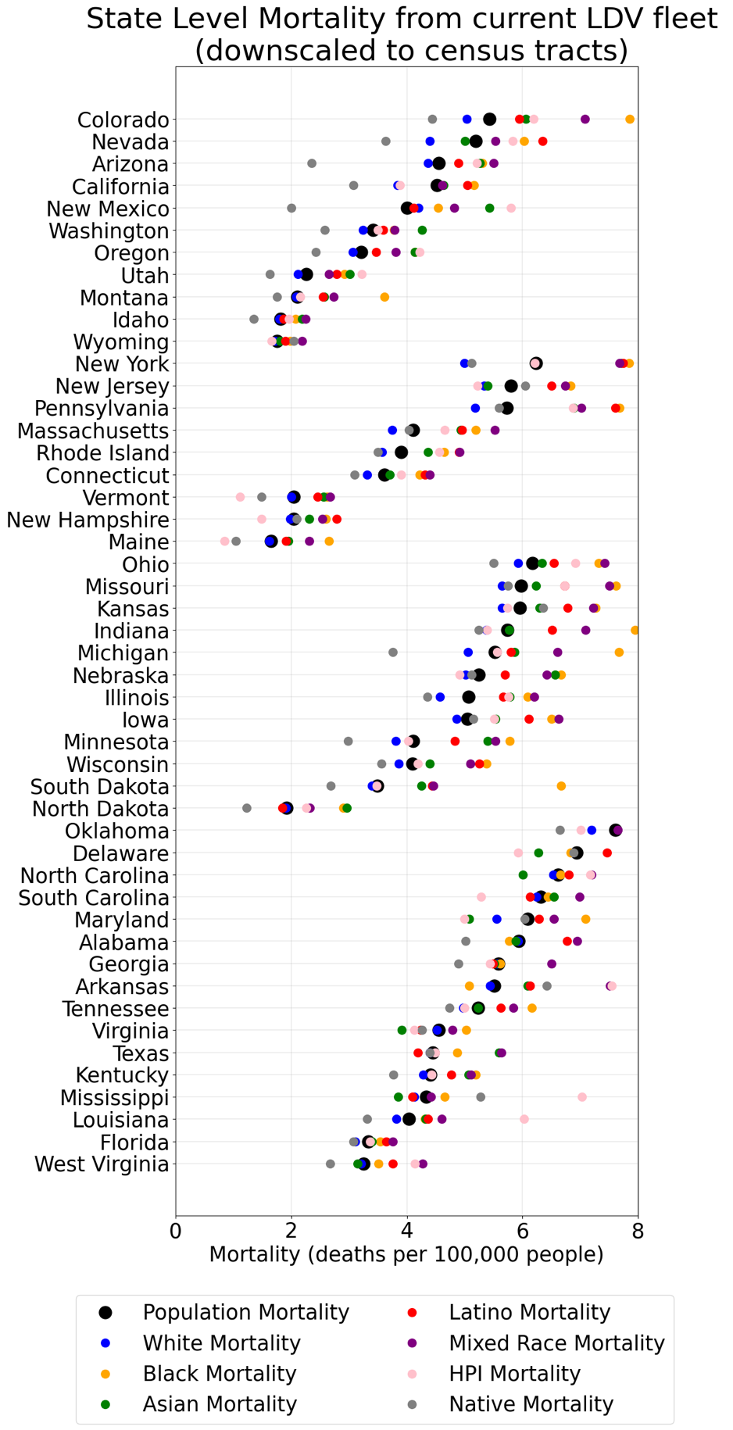

Figure S 18 : State level total and race/ethnicity specific mortality rate for the current LDV fleet (downscaled to census tract).

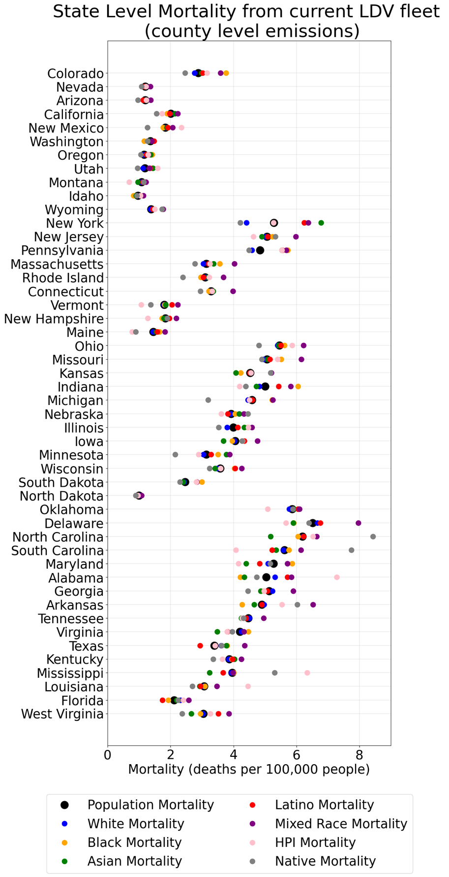

Figure S 19 : State level total and race/ethnicity specific mortality rate for the current LDV fleet (county level input as per NEI 2017).

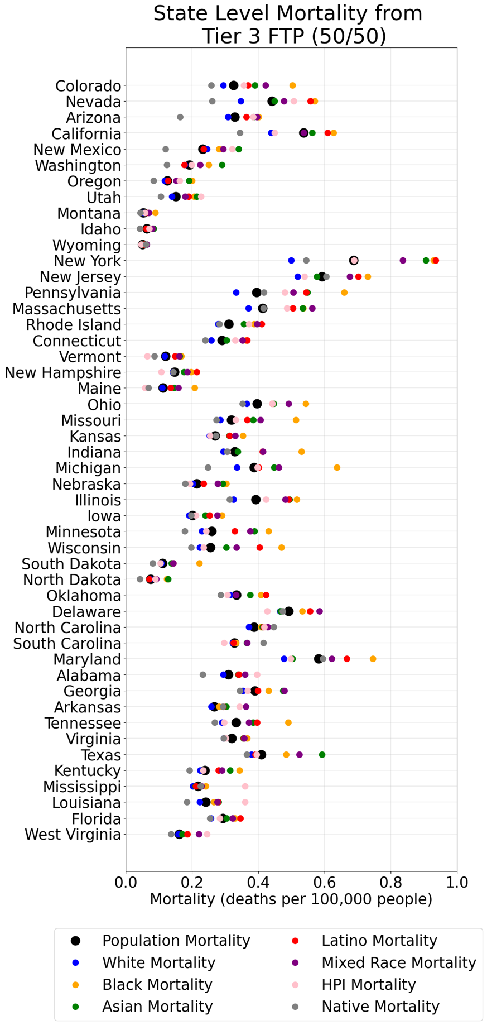

Figure S 20 : State level total and race/ethnicity specific mortality rate for Tier 3 ICV (FTP, 50/50)

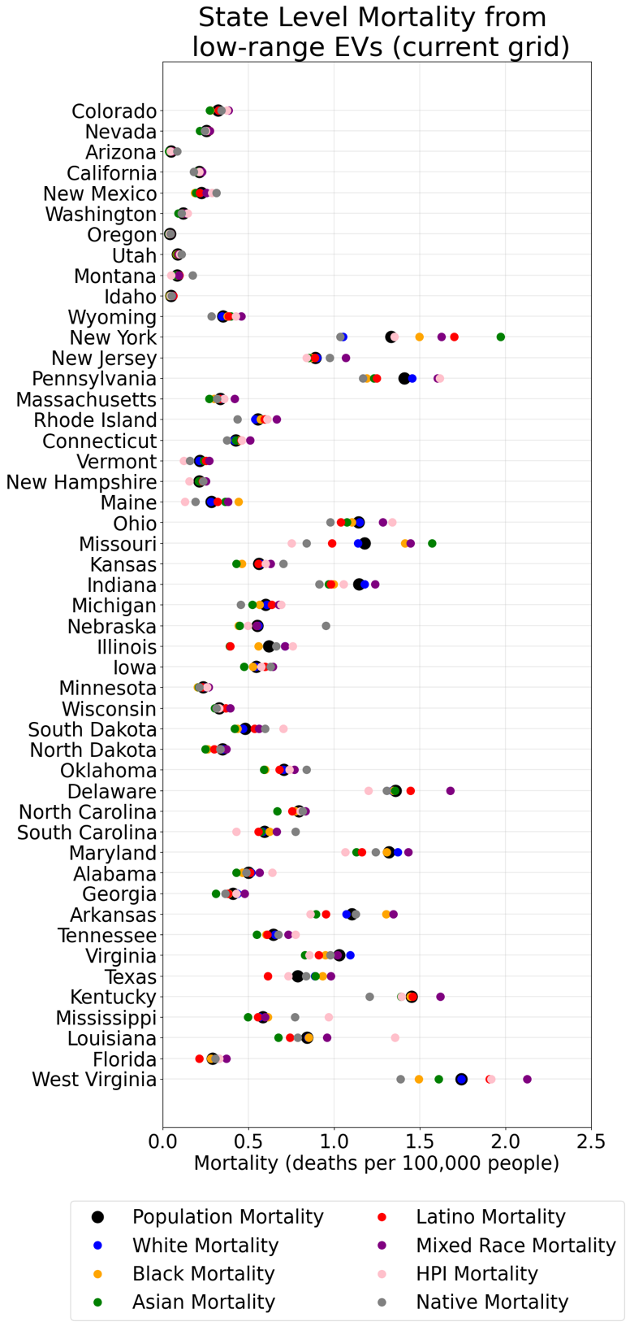

Figure S 21: : State level total and race/ethnicity specific mortality rate for low range EV (future grid)

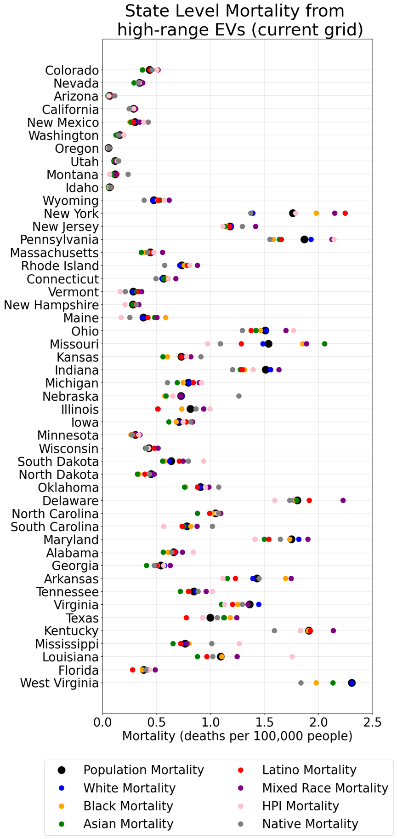

Figure S 22 : State level total and race/ethnicity specific mortality rate for high range EV (future grid)

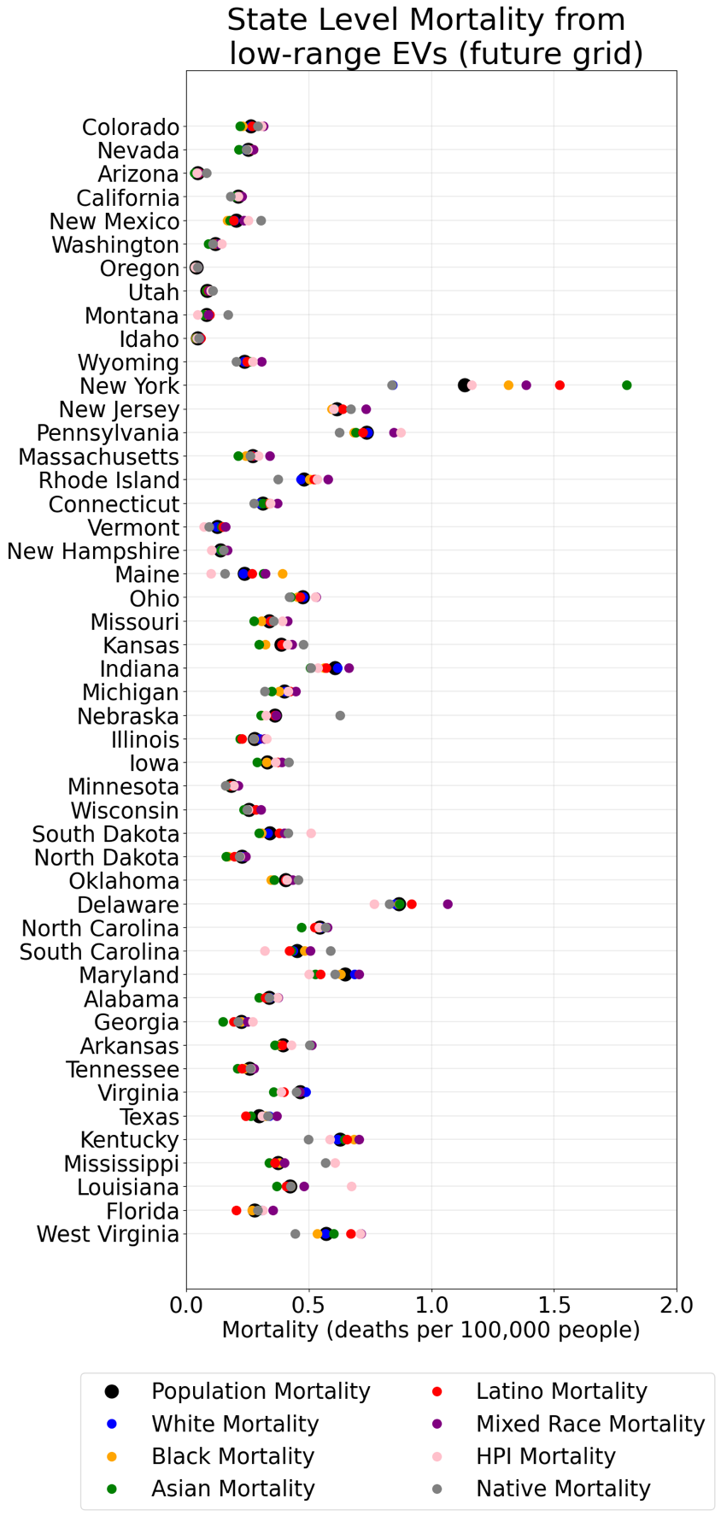

Figure S 23: State level total and race/ethnicity specific mortality rate for low range EV (future grid)

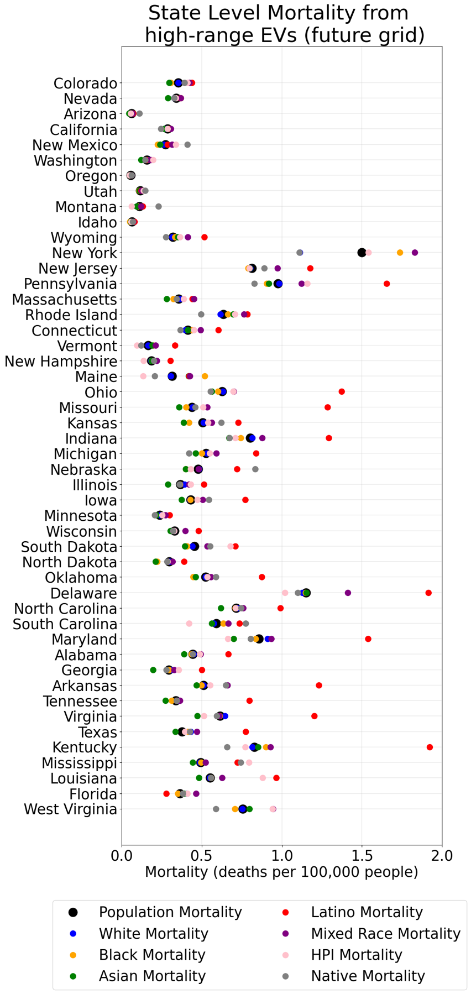

Figure S 24: State level total and race/ethnicity specific mortality rate for high range EVs (future grid).

1. **Income and urbanization disaggregated results for Tier 3 SFTP (50/50) and EVs (long range) on future grid (50 highest SO2 polluting power plants are retired or retrofit with CCS)**

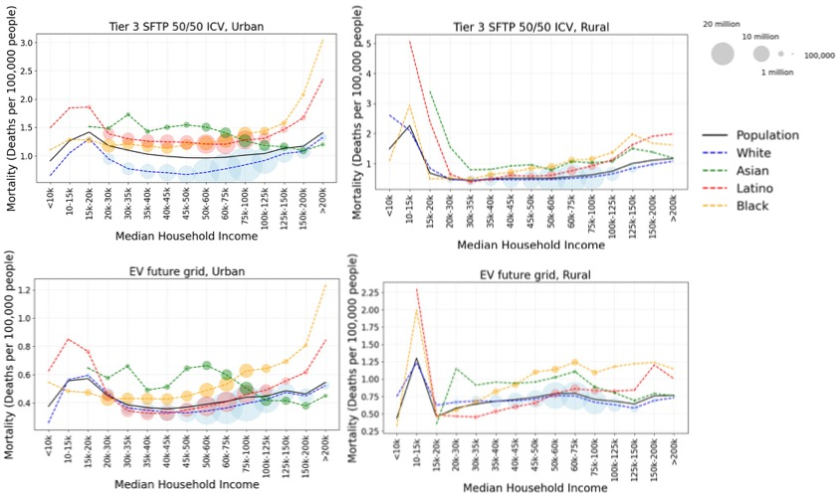

Figure S 25 : Transport attributable premature mortality for Tier 3 SFTP (50/50) and EVs charged on future grid and dependence on median household income in rural and urban census tracts. Census tracts with population density more than 500 per square mile are characterized as urban. Note different Y axis limits.

[1] “High-Resolution Air Pollution Mapping with Google Street View Cars: Exploiting Big Data | Environmental Science & Technology.” Accessed: Jul. 03, 2023. [Online]. Available: https://pubs-acs-org.stanford.idm.oclc.org/doi/10.1021/acs.est.7b00891

[2] Y. Li, D. K. Henze, D. Jack, and P. L. Kinney, “The influence of air quality model resolution on health impact assessment for fine particulate matter and its components,” *Air Qual Atmos Health*, vol. 9, no. 1, pp. 51–68, Feb. 2016, doi: 10.1007/s11869-015-0321-z.

[3] T. Wolf, L. H. Pettersson, and I. Esau, “A very high-resolution assessment and modelling of urban air quality,” *Atmospheric Chemistry and Physics*, vol. 20, no. 2, pp. 625–647, Jan. 2020, doi: 10.5194/acp-20-625-2020.

[4] J. Tan, Y. Zhang, W. Ma, Q. Yu, J. Wang, and L. Chen, “Impact of spatial resolution on air quality simulation: A case study in a highly industrialized area in Shanghai, China,” *Atmospheric Pollution Research*, vol. 6, no. 2, pp. 322–333, Mar. 2015, doi: 10.5094/APR.2015.036.

[5] “Local Area Transportation Characteristics for Households (LATCH Survey) | Bureau of Transportation Statistics.” Accessed: Mar. 14, 2023. [Online]. Available: https://www.bts.gov/latch

[6] “Local Area Transportation Characteristics for Households Data | Bureau of Transportation Statistics.” Accessed: Mar. 14, 2023. [Online]. Available: https://www.bts.gov/latch/latch-data

[7] “Emission Standards: USA: Cars and Light-Duty Trucks—Tier 1.” Accessed: Nov. 17, 2022. [Online]. Available: https://dieselnet.com/standards/us/ld_t1.php

[8] O. US EPA, “Final Rule for Control of Air Pollution from Motor Vehicles: Tier 3 Motor Vehicle Emission and Fuel Standards.” Accessed: Feb. 13, 2022. [Online]. Available: https://www.epa.gov/regulations-emissions-vehicles-and-engines/final-rule-control-air-pollution-motor-vehicles-tier-3

[9] O. US EPA, “EPA Emission Standards for Light-Duty Vehicles and Trucks and Motorcycles.” Accessed: Mar. 20, 2023. [Online]. Available: https://www.epa.gov/emission-standards-reference-guide/epa-emission-standards-light-duty-vehicles-and-trucks-and

[10] C. W. Tessum, J. D. Hill, and J. D. Marshall, “InMAP: A model for air pollution interventions,” *PLoS ONE*, vol. 12, no. 4, p. e0176131, Apr. 2017, doi: 10.1371/journal.pone.0176131.

[11] “Annual Certification Data for Vehicles, Engines, and Equipment.” Accessed: Jun. 09, 2022. [Online]. Available: https://www.epa.gov/compliance-and-fuel-economy-data/annual-certification-data-vehicles-engines-and-equipment

[12] T. Yuksel and J. J. Michalek, “Effects of Regional Temperature on Electric Vehicle Efficiency, Range, and Emissions in the United States,” *Environ. Sci. Technol.*, vol. 49, no. 6, pp. 3974–3980, Mar. 2015, doi: 10.1021/es505621s.

[13] T. Yuksel, M.-A. M. Tamayao, C. Hendrickson, I. M. L. Azevedo, and J. J. Michalek, “Effect of regional grid mix, driving patterns and climate on the comparative carbon footprint of gasoline and plug-in electric vehicles in the United States,” *Environ. Res. Lett.*, vol. 11, no. 4, p. 044007, Apr. 2016, doi: 10.1088/1748-9326/11/4/044007.

[14] M. Singh, T. Yuksel, J. Michalek, and I. M. L. Azevedo, “How clean does the U.S. electricity grid need to be to ensure electric vehicles reduce greenhouse gas emissions when compared to hybrid gasoline vehicles?”.

[15] O. US EPA, “Emissions & Generation Resource Integrated Database (eGRID).” Accessed: Jan. 24, 2022. [Online]. Available: https://www.epa.gov/egrid

[16] “HEI Research Report 140,” p. 154.

[17] J. Lepeule, F. Laden, D. Dockery, and J. Schwartz, “Chronic Exposure to Fine Particles and Mortality: An Extended Follow-up of the Harvard Six Cities Study from 1974 to 2009,” *Environ Health Perspect*, vol. 120, no. 7, pp. 965–970, Jul. 2012, doi: 10.1289/ehp.1104660.

[18] R. Burnett *et al.*, “Global estimates of mortality associated with long-term exposure to outdoor fine particulate matter,” *Proc Natl Acad Sci USA*, vol. 115, no. 38, pp. 9592–9597, Sep. 2018, doi: 10.1073/pnas.1803222115.

[19] C. W. Tessum *et al.*, “Inequity in consumption of goods and services adds to racial–ethnic disparities in air pollution exposure,” *PNAS*, p. 201818859, Mar. 2019, doi: 10.1073/pnas.1818859116.

[20] M. M. Nasari *et al.*, “A class of non-linear exposure-response models suitable for health impact assessment applicable to large cohort studies of ambient air pollution,” *Air Qual Atmos Health*, vol. 9, no. 8, pp. 961–972, Dec. 2016, doi: 10.1007/s11869-016-0398-z.

[21] P. Hystad, S. Yusuf, and M. Brauer, “Air pollution health impacts: the knowns and unknowns for reliable global burden calculations,” *Cardiovascular Research*, vol. 116, no. 11, pp. 1794–1796, Sep. 2020, doi: 10.1093/cvr/cvaa092.

[22] “US Census divisions and regions.” Accessed: Mar. 22, 2023. [Online]. Available: https://www2.census.gov/geo/pdfs/maps-data/maps/reference/us_regdiv.pdf

[23] J. S. Apte, J. D. Marshall, A. J. Cohen, and M. Brauer, “Addressing Global Mortality from Ambient PM 2.5,” *Environ. Sci. Technol.*, vol. 49, no. 13, pp. 8057–8066, Jul. 2015, doi: 10.1021/acs.est.5b01236.

1. <https://gaftp.epa.gov/air/nei/2017/doc/supporting_data/onroad/> folder name : 2017NEI_onroad_activity_final, filename : VMT_2017NEI_final_form_CDBs_month_redist_27mar2020_v3.csv, specific codes to filter highway vehicles – gasoline passenger cars : 2201210200, 2201210300, 2201210400, 2201210500; gasoline passenger trucks : 2201310200, 2201310300, 2201310400, 2201310500
2. https://www.epa.gov/emission-standards-reference-guide/epa-emission-standards-light-duty-vehicles-and-trucks-and
3. Prior to Tier 3 regulations, NOx and NMOG had separate emission limits. There is no mandated fleet average for PM, CO and HCHO.
4. Manufacturers must certify their vehicles to one of the seven emissions bins shown in SI table 3. An automaker’s fleet (i.e, all the cars they produce in a given model year) must meet a specified NMOG + NOX average annually. The fleet average limit is lowered each year until model year 2025. The noted fleet average is for the model year 2022 and end goal of the regulation (model year 2025). A certain percentage of the automaker’s fleet must achieve the set PM emission limit (0.003 gram/mile) each year; this percentage increases every year until reaching 100% in MY 2021. There is no mandated average for CO or HCHO and each vehicle must abide by PM emission standard.
5. The SFTP standard for PM is to be met over the US06 test, representing aggressive highway driving.